Join us

I like this format of choice. The link should take the person to a separate webpage.
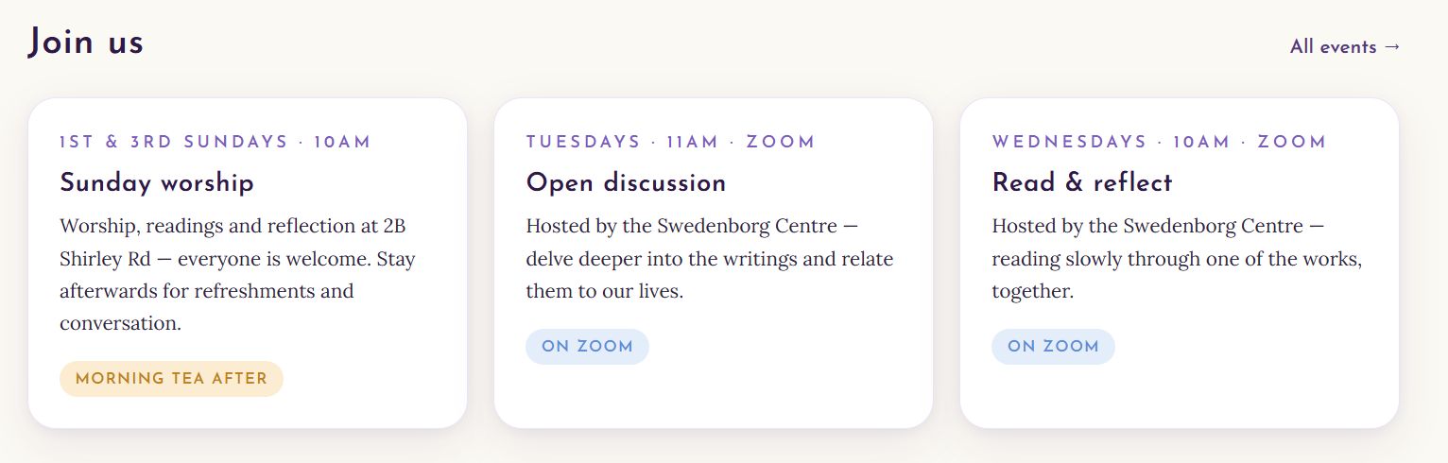
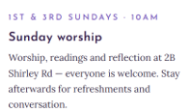

Here (Hyperlink to Sunday Worship webpage) you'll find everything you need to know if you're interested in joining us on a Sunday.

Sunday Worship webpage
Join us on Sunday

We would love to welcome you to one of our Sunday worship services.

Our services are held on the first and third Sunday of each month, beginning at 10:00 am, and usually last 45–55 minutes. On the first Sunday of the month we also celebrate the Holy Supper, during which blessed bread and wine are shared with those who wish to participate.

If you've never visited our church before, you may be wondering what to expect. We know that walking into a new church can feel a little daunting, so we want you to know that you'll be warmly welcomed. Whether you're exploring the Christian faith, interested in the teachings of the New Church, or simply looking for a place to reflect and worship, you are very welcome here.

Before the service begins, you'll find a quiet, peaceful atmosphere with music playing as people prepare for worship. You'll be given a service booklet containing the order of service and the words of the hymns, so it's easy to follow along, even if it's your first visit.

The service begins with the singing of an opening hymn. During the service we have readings from the Bible and the writings of Emanuel Swedenborg, pray together, sing hymns, and listen to a sermon that explores the theme for the day. The message is intended to offer practical spiritual insights that encourage and support us in our everyday lives.

After the service, everyone is invited to stay for tea, coffee, and refreshments. It's a relaxed opportunity to meet people, enjoy conversation, and get to know our church community. Our pastor is always happy to answer questions about the service, the New Church, or anything else you may be curious about.

A freewill offering may be placed in the offering pouch at the back of the sanctuary to help support the work of the church. We do not take up an offering during the service, and if you are visiting for the first time, please feel no obligation to contribute. We are simply glad that you have joined us.

We hope you'll feel at home here and leave encouraged, refreshed, and inspired. If you have any questions before your visit, please don't hesitate to get in touch. We look forward to welcoming you.

Morning tea afterwards.
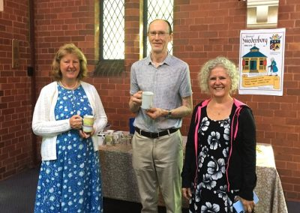
Faith that makes sense. A welcoming Christian community in Roseville.
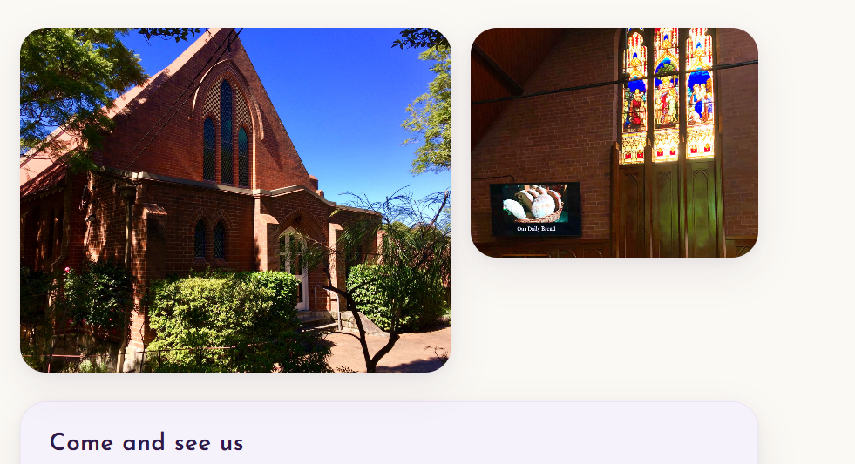

2B Shirley Rd, Roseville NSW 2069 – ten minutes’ walk from Roseville Station.
The Swedenborg Centre is next door at 4 Shirley Rd.
Church Office: 02 9416 7026


Testimonials from people who attend and have attended the Roseville New Church

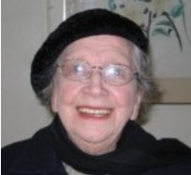  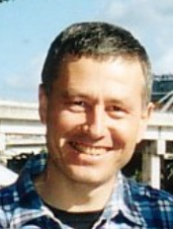  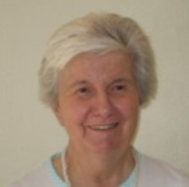 |  | "I was born into the New Church in 1914, married there, so have had the privilege of learning that the Word is nothing but the doctrine of love to our Lord and charity towards our neighbour. We have been led by the writings of Emanuel Swedenborg. Church for me is happiness, especially as some members were with me when we were young and our minister imparts true love with his service." (Joan Aronsten)  "What I like about coming to New Church services is that the message radiates the energy of Love and Truth. I started attending in the early 1990s when Julian was our minister. He has a deep love of the Bible and coming from a Swedenborgian background, opened up many of the stories so that one sees the relevance of the passages in one's own life. Another name for our group that I privately use is 'The Church of the Open Word' as it expresses my experience that the inner meanings of the Bible are opened up here. The people attending are very friendly and I enjoy being with them afterwards when we gather for morning tea." (Michael Chester)  "I was first attracted to the New Church by a neighbourhood "welcome" letter from the Minister in 1991. I continue to appreciate the following: helpful answers to hard questions; the concepts of "regeneration" and personal responsibility; opportunities to share ideas; each other as good friends; occasions of feeling and giving joy. I enjoy learning about the deeper meaning of the Bible which leads us in our personal growth. There is very little use of the words guilt or sin, but recognition of the universality of all faiths. " (Stella Green)

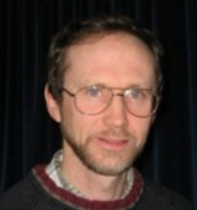  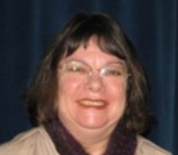  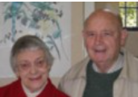   |  | "Many years ago when I left school, I was ready to embark on a search for the Truth. Before too long I stumbled upon the teachings of the New Church and my search was over. But in another sense, it had just begun because this Truth is never-ending in what it reveals to me." (Wayne Kasmar)  I find the teaching at the New Church always helpful. Our group is thoughtfully led by our minister assisted by his wife. I first entered the church as a bridesmaid at the wedding of friends, and became a member in 2001. (Lillian King)  "It was being impressed by the influence of Swedenborg on Helen Keller that directed me to seek out the Swedenborg Centre and from there discovered the New Church based on Swedenborg's teachings and there I found a community. "A happy band of pilgrims" which made me feel comfortable and accepted without judgement." (Bobbie Page)  "I come to the New Church because of the gentle humanity that pervades each meeting there whether this is one to one with the minister or is one of the many functions (both religious and secular) conducted there. Whether the view expressed always agrees with mine is not important, it always stimulates self consideration and pondering." (Roy Simmonds)

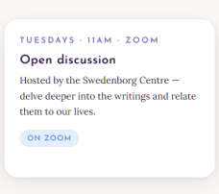

Join our Weekly Open Discussion Sessions
Tuesdays – 11 am to 1pm – In person or via Zoom
Hosted by the Swedenborg Centre, 4 Shirley Rd, Roseville

You're warmly invited to join our weekly Open Discussion, held on Tuesdays.
This is an open, friendly conversation where everyone is welcome, whether you're new to Swedenborg's writings or have been exploring them for many years. There are no formal presentations—just thoughtful discussion in a relaxed and respectful atmosphere.

Feel free to bring a question, a passage from Swedenborg's writings, or a topic that has arisen in your own spiritual journey. Together we explore how spiritual teachings can help us better understand ourselves, our relationships, and the deeper meaning of everyday life.

While Swedenborg's writings provide the foundation for our discussions, we also enjoy exploring insights from other wisdom traditions where they shed light on similar spiritual themes. Past conversations have included topics from Advaita Vedanta, Shin Buddhism, and the Fourth Way teachings of G.I. Gurdjieff and P.D. Ouspensky. Looking at timeless spiritual questions through different lenses often deepens our understanding and appreciation of Swedenborg's teachings.

There is no expectation that you have read Swedenborg or are familiar with these traditions. Curiosity, thoughtful questions, and a willingness to explore are all you need. We would be delighted to welcome you and hear your perspective.

The Zoom link and dates can be found at https://swedenborg.com.au/events/

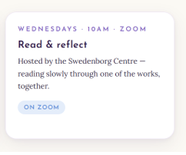

Join our Weekly Swedenborg Reading and Exploration Sessions
Wednesdays – 10 am to noon – In person and Zoom
Hosted by the Swedenborg Centre, 4 Shirley Rd, Roseville

You're warmly invited to join our weekly Swedenborg reading and exploration on Wednesdays. Together we read and discuss passages from Emanuel Swedenborg's writings, taking time to reflect on their spiritual meaning and how they can enrich our understanding of everyday life. Whether you are new to Swedenborg or have been reading his works for many years, you are very welcome.

We are currently exploring True Christianity (also published as True Christian Religion), Swedenborg's comprehensive presentation of his central theological teachings. Each session focuses on a small section of the text, with plenty of opportunity for questions, discussion, and sharing insights.

There's no need to have attended previous sessions. We begin each week with a brief overview of the context, making it easy to join at any point in the series.

Come along with curiosity, bring your questions, and enjoy exploring these profound ideas in a friendly and welcoming group.

The Zoom link and dates can be found at https://swedenborg.com.au/events/

Other events
Monday’s Meditation with Kathryn Baker
Kathryn Baker has been guiding members of our community in meditation for many years. Recently there has been an upsurge in activity and Kathryn has returned to a regular Monday morning meditation held in the quiet of the church sanctuary. In today’s ever-changing, fast-paced and sometimes overwhelming life, meditation offers a gentle respite—an opportunity to re-centre, quiet the mind and become more aware of the comforting presence of the Divine. Even a short time of stillness can soften anxiety, renew focus, and deepen our capacity to love and serve. If interested, feel free to join the group any Monday at 10:00am. If you’d like to speak with Kathryn before coming along, feel free to contact her at ph. 0410 166 482.
(Check with Kathryn first)

Upcoming Events

New Church in Australia Family Retreat
22–26 January 2027
The Tops Conference Centre, 51 Bendena Gardens, Stanwell Tops, NSW
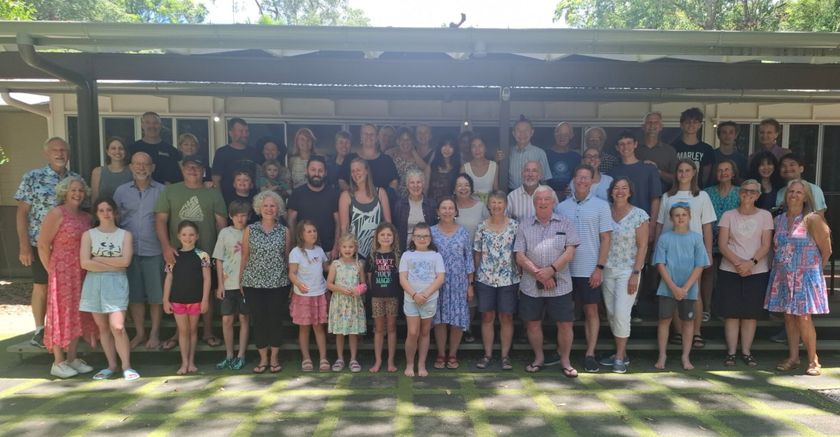
You're warmly invited to join us for the 2027 New Church in Australia Family Retreat.
Whether you're coming for the first time or returning to reconnect with old friends, the retreat offers a welcoming space to step away from the busyness of everyday life, deepen your spiritual life, and enjoy the company of people of all ages.

Over five days you'll find a relaxed blend of inspiring talks and discussions, worship, creative and recreational activities, shared meals, and plenty of opportunities for conversation, laughter, and quiet reflection. Families, couples, singles, and people who are simply interested in exploring spirituality are all welcome.
You are welcome to stay for the entire retreat or, if you are unable to do so, visit as a day guest.
Below you'll find everything you need to plan your visit:
- Retreat Information – details about the venue, accommodation and costs. Includes a QR code that links directly to the booking form.
- Online Booking Form – register your interest and book your place.
- Day Visitor Information – for those planning to attend for a single day.

We hope you'll join us for a time of spiritual refreshment, meaningful friendships, and the simple joy of sharing life together in a beautiful natural setting.

Community events
Movie night ????
Get details from Joe.

